

2 Minute Form
Trip Name: Cornwallis to Whatipu
Check-in Name and Phone:
Date: Branch:
Leaders
Cell Phone Number
VHF Call Sign &/or Vessel Name
Vehicle make, model, registration, colour
General Plan
Note: If plan changes, you must notify your Check-in person.
Latest Time Off the Water |  |  |  |  | TMP used²⁰
Tide/ Forecast Lake Level | Low |  |  | High | Other
Communications Carried²¹
Communications | We will be communicating as a group on VHF Channel
Equipment Carried
Trip Report
(Use other side if more space required)

Activity | Yakity Yak Club trip | Centre | Auckland | Location |  |  |  | Manukau |  | Difficulty¹ |  |  |  | Intermediate – not suitable for beginners in any conditions.
Activity Description | Launch at Cornwallis Wharf, paddle with the outgoing tide to Whatipu. Return with the incoming tide.  Option B is to cross to the southern side of the harbour and paddle down that side where it may be more sheltered depending on wind speed and direction. |  |  |  | Leader qualification req.² |  |  | Club leader
Get in Location | Cornwallis |  |  |  | Chart/ Map no.⁴ |  |  | NZ 4314 |  | Distance |  |  |  | Approx 25KM
Get out Location | Cornwallis |  |  |  | Coastguard Channel - Manukau |  |  | 81 & 16 |  | Nowcasting |  |  |  | 21
Emergency get out ⁵ | Beaches along the way |  |  |  | Emergency / Coastguard Station |  |  | Auckland |  | Phone |  | *500 / 09 303 4303
Emergency get out ⁵ |  |  |  |  | Drinking Water⁶ |  | No |  | Toilets⁷ |  |  |  | At Cornwallis & Whatipu
Emergency Response | Refer Emergency Response Booklet |  |  |  |  |  |  |  | Parking⁸ |  |  |  | At Cornwallis
Specific Equipment Required⁹ | None |  |  |  | Working Communications equipment in this area¹⁰ |  | Cell phone  Sat phone |  |  |  | Mountain Radio |  |  |  | PLB  VHF
Other resources  and notes¹¹ |  |  |  |  | Weather Parameters¹² | Beginner: no significant surf or swell, wind under 15 knots.  Intermediate: surf or ocean swells less than 1.5 metres or wind under 25 knots.  Advanced: any condition that’s suitable for the trip’s aims.
Previous incidents¹³

Safety Management¹⁴
Hazard |  | Significant?  - E/I/M |  | Management Strategy¹⁵ |  |  |  | Hazard | Significant?  - E/I/M | Management Strategy¹⁵
Cold Water |  | Yes - M |  | Carry spare dry clothes and shelter |  |  |  | Deep Water | Yes - E | Correctly fit PFDs
Medical Conditions |  | Yes - M |  | - Leader has first aid qualification  - Ask customers about medical conditions |  |  |  | Bad Weather | Yes - M | Understand weather forecasts.  Have back up plans or pull out if necessary
Capsizing |  | Yes - M |  | - Correctly fit PFDs  - Skills at performing rescues. |  |  |  | Heat / Sun | Yes - M | - Protective Clothing (worn), Sunglasses, Hat  - Sun Screen  - Plenty of drinks
Panic |  | Yes - M |  | Ensure conditions match level  of skills |  |  |  | Obstacles | Yes - M | Awareness of reefs, navigational hazards, nets
Tidal Flows |  | Yes - M |  | There is a strong tidal flow around the Cornwallis peninsula, and in some conditions the water can be very rough off the point. At full flow it can be impossible to paddle against it.  There is a lot of water moving through a narrow harbour entrance. Stay close to shore to ensure that participants don’t get dragged out to the bar.  Ensure participants have the required skills. |  |  |  | Other Vessels | Yes - M | - Understand the “rules of the sea”  - “Be seen” – Have two of the following; flag, brightly coloured kayak, brightly coloured Pfd or hat. At night: an all- round white light & a powerful torch.
Manukau Bar |  | Yes – M |  | The bar at the entrance to the Manukau Harbour is very dangerous. Take care not to be carried onto it with the outgoing tide. Know what the tides are doing during the time of the trip.
Written up by: | Larraine Williams |  | Approved By: |  | Russell Williams | Signed: | RW |  | Date: | 18 Nov 2014 | Review in: | 12 months from date of approval

Additional Information Sheet (Optional)
Introduction (A general introduction)
Description (A description of the tour – as if you were selling the idea to someone)
Local Attractions |  | Transport/ Local Operators
 | Contact details |  | Contact details
Local Eateries
 | Contact details
Accommodation/ Campsite Locations |  |  | Facilities
Name |  |  | Cabins |  | Fuel
Phone |  |  | Showers |  | Power
E-mail |  |  | Toilets |  | Water Access
Website |  |  | Laundry |  | Pool
Physical Address |  |  | Water |  | Fires Allowed
Other |  |  | Supplies
Other information

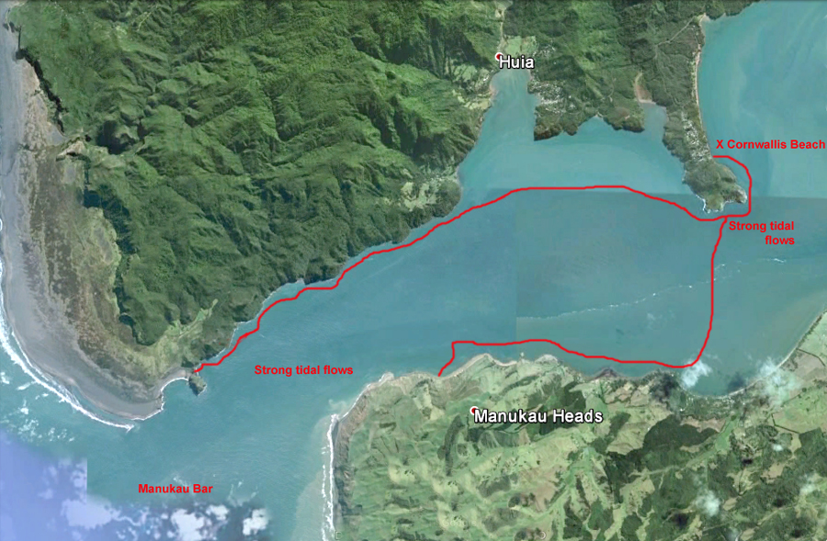

Activity Equipment Check list
Equipment List
- Helmet (rivers & surf) Group Gear
❑ Beanie / hat  Split paddles
❑ Thermals  Repair kit
❑ Paddle Jacket  Fire lighting
❑ PFD  Cooker/thermos
❑ Spray deck  Spare thermals
❑ Booties  Tow system
❑ Water & food  1st Aid Kit
❑ Kayak & paddle  Flares
Group - Oceans & Lakes  Compass
❑ Pumps & Paddle Floats  Charts / Maps
Group - River  GPS (optional)
❑ Throw ropes  Knife (cut rope)
❑ Pin kit & saw  Emergency Shelter

In case of emergency: Dial 111, Mayday :VHF Channel 16

Kayaking Check list

❑ Trip plan
❑ Latest weather forecast
❑ Conditions match skills?
❑ Hyperthermia (hot) &
Hypothermia (cold)
❑ On & off water safety
❑ Environmental concerns
❑ Emergency Procedures include emergency get out.
❑ Working communication devices
e.g. VHF radio, mobile phones, PLB
❑ Specific safety issues for this trip
❑ Participant list
❑ Any medical conditions
❑ All participants keen to proceed?

❑ Trip Plan/ 2-minute form lodged with Ops. Manager

Appropriate wind conditions to run trips:
Novice - no significant surf or swell, wind under 15knots
Intermediate- surf or ocean swells less than 1.5 metre or wind under 25 knots.
Advanced- any condition that is suitable to the trips aims

At conclusion of trip:
Contact check in person
Group Debrief.

Check in Person Ph:
__________________ Mobile
__________________ Work
__________________ Home

Activity Document Cover Sheet

Activity:
Date of Activity:

Activity reports. Is all relevant information present:
– Approved Trip Management Plan (TMP)/ 2 minute form
– Club Trip Participant Sheet
– Weather forecast
– Activity Check List
– Trip report (May be on the 2 minute form)
– Accident / incident reports
Leaders Signature:
Date:

